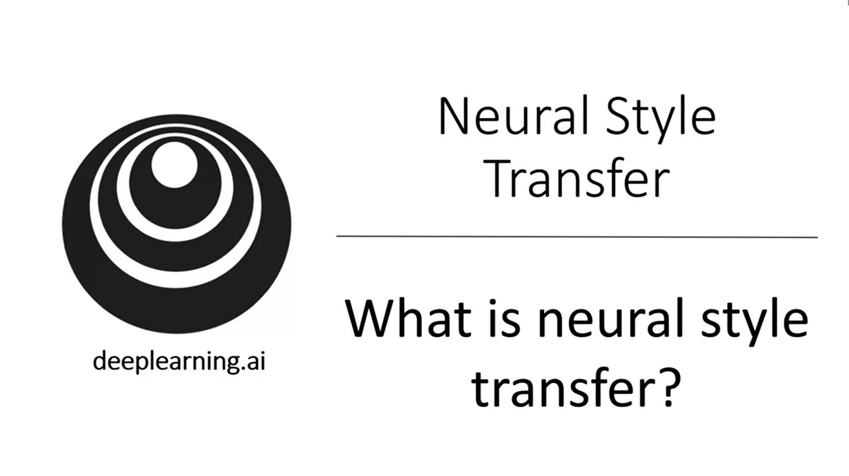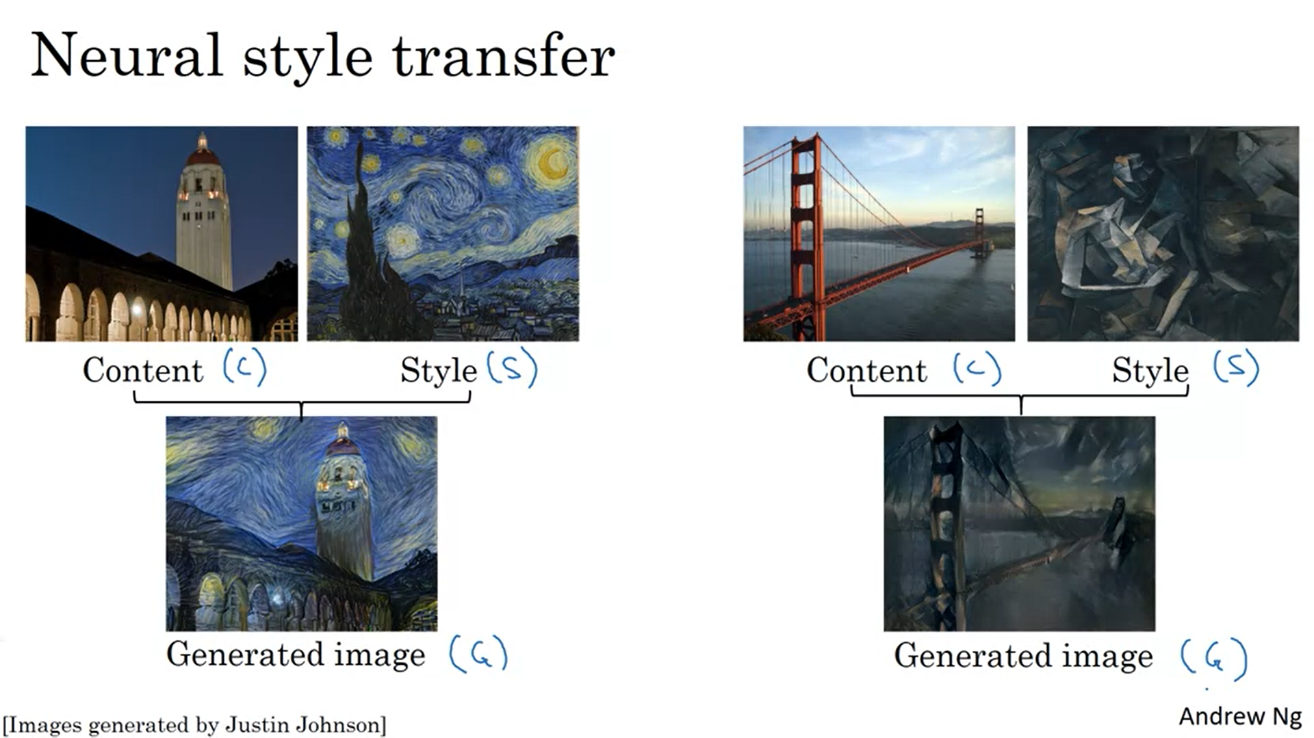

Let’s look at examples. Generate a new image from a content and style image.

In order to implement neural style transfer we need to look at the features that a convnet extracts at various layers.

Andrew first wants to give us intuition about what all the layers of a network are really computing.

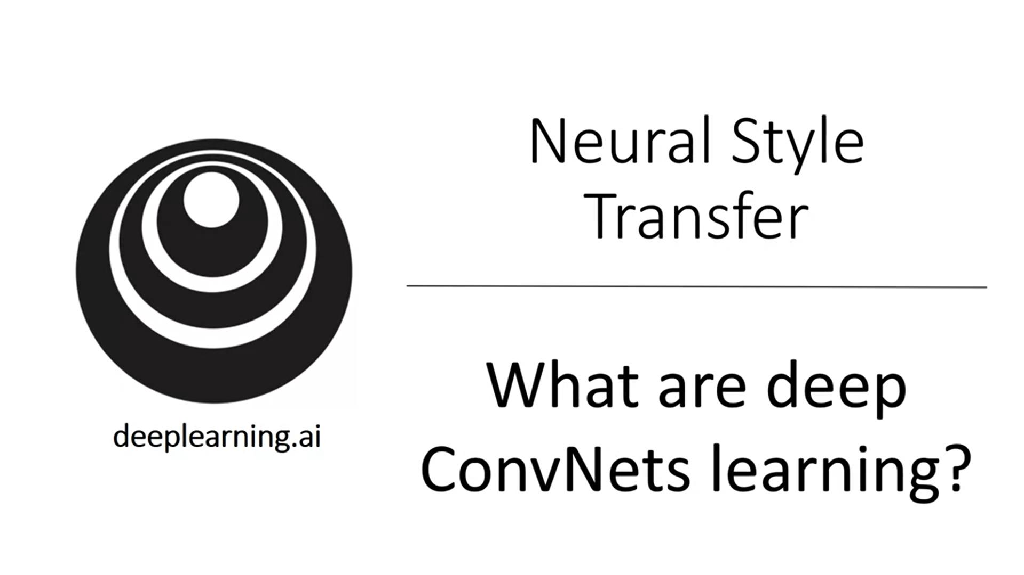Let’s hone our intuition.

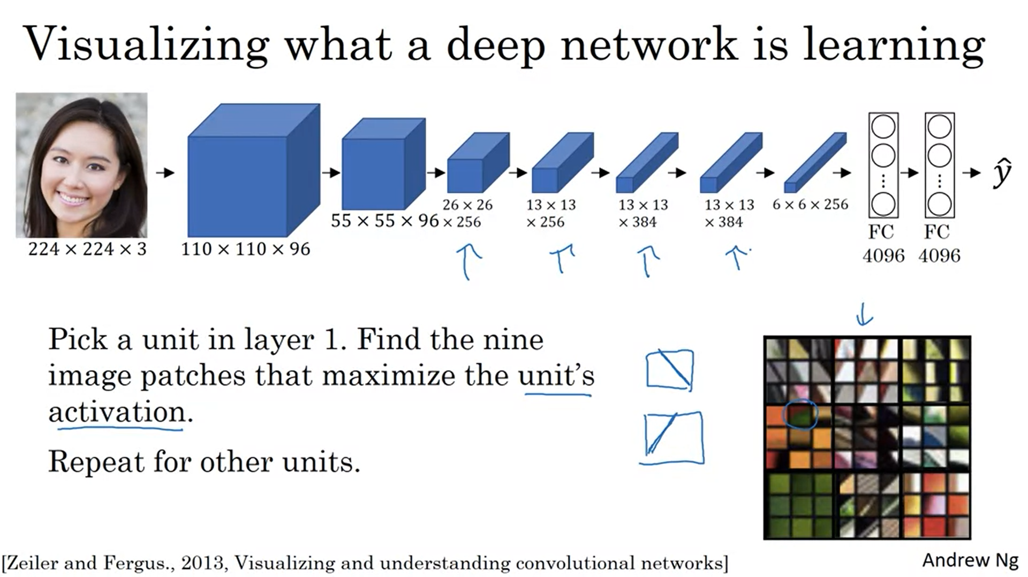

A hidden unit in the early layers only sees a small patch of the image. Scan through the training set and find out which are the images / image patches that maximize the activation of a particular unit in the first layer.

Find the 9 input images (image patches) that maximize the activation of that hidden unit. It seems like it is detecting diagonal edges to the bottom right. Then do the same for a different hidden unit in layer 1. The next 9 input images detect diagonal edges to the top right. Then do the same for 7 more hidden units to get the above picture.

Trained units in layer 1 are looking for simple things such as edges or different shapes of color.

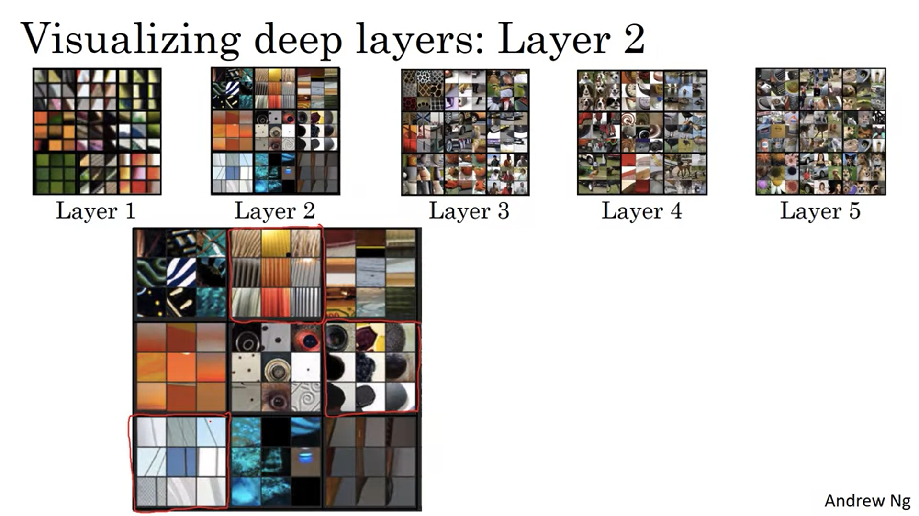

Do the same thing for deeper layers. One unit will then see a larger part of the image (a larger image patch). The visualizations above always show the 9 image patches that maximize the activation for 9 different units.

Let’s zoom in to layer 2. Layer 2 detects more complex shapes and patterns (e.g. lots of vertical lines next to each other; roundish shape…)

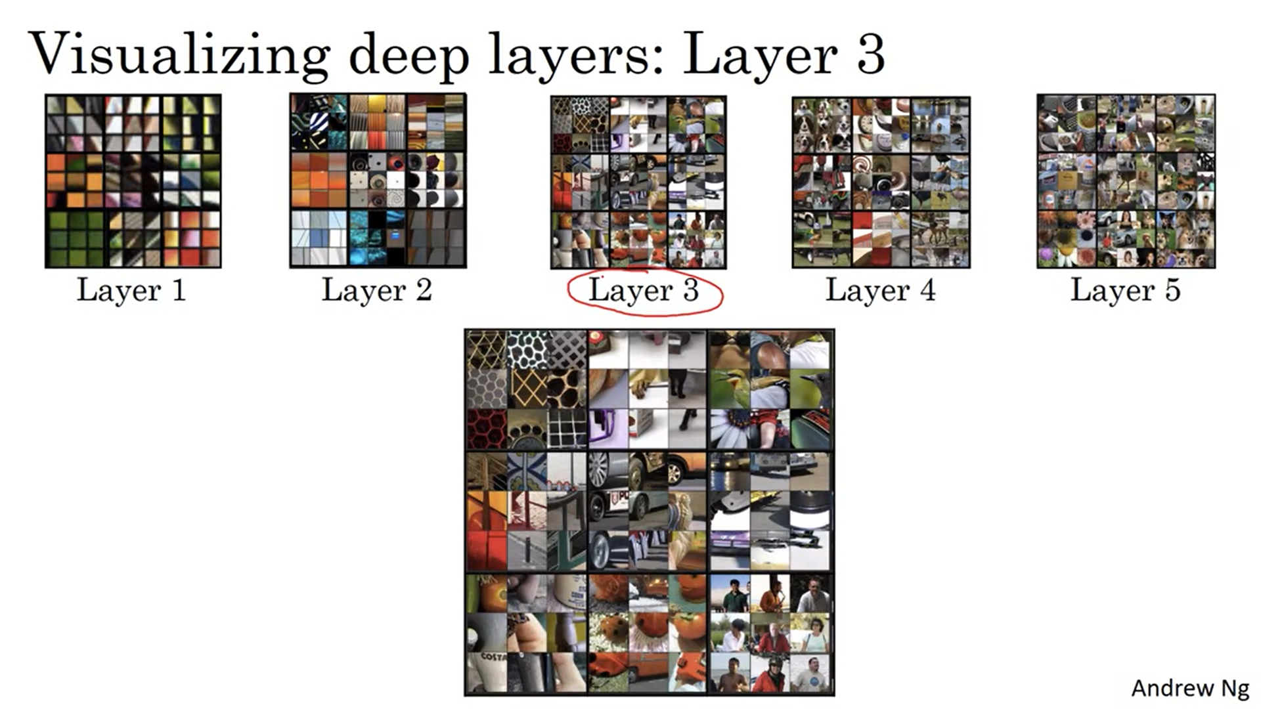

Let’s zoom in to layer 3.

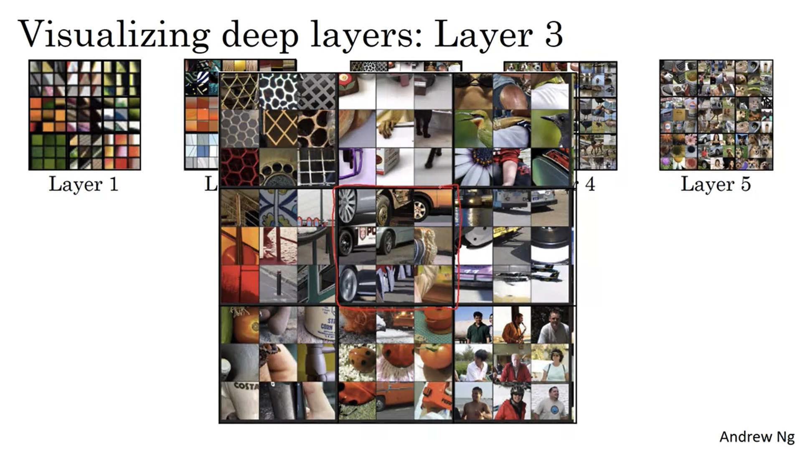

It seems like there is 1 unit which starts to detect people, another unit starts to detect car tires etc.

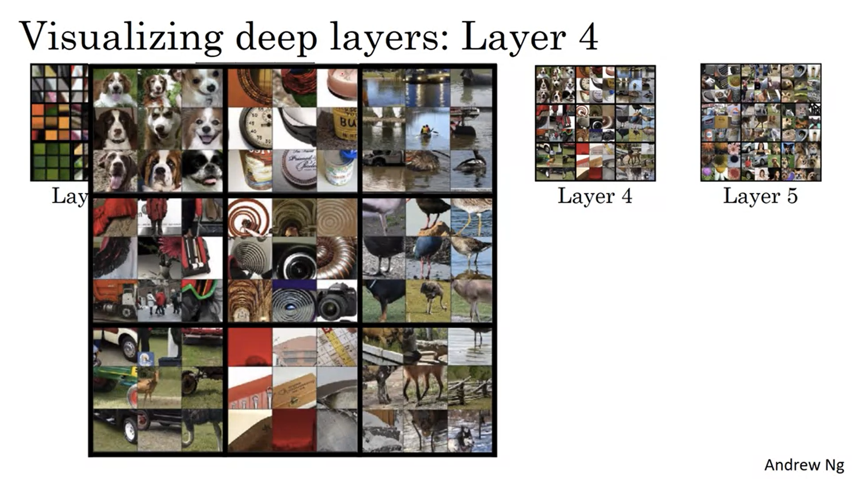

Layer 4 is even more complex. One unit is almost a dog detector (although they look quite similar); another layer is detecting water; yet another is detecting birds and so on.

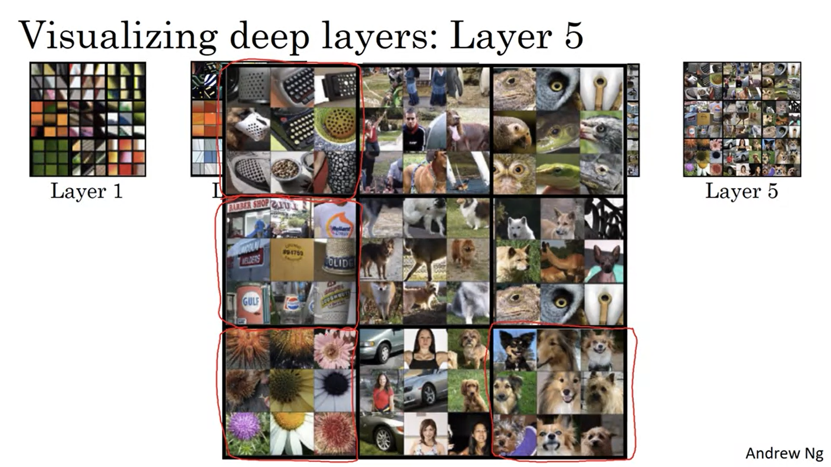

This continues with layer 5. Now there is a unit which seems to be a dog detector for different species; another unit detects keyboard and keyboard-like textures; yet another detects flowers.

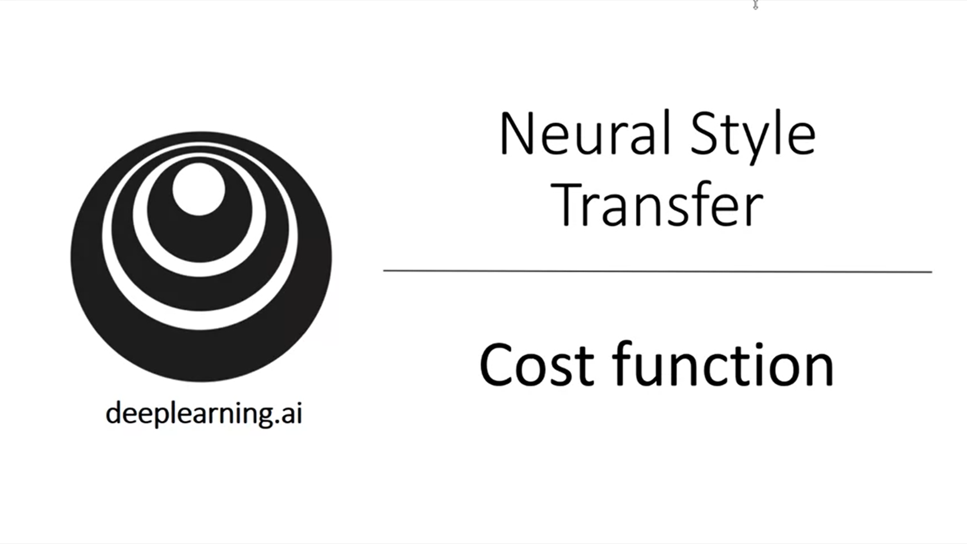By minimizing the cost function we can generate a new image. Goal: create a new image G.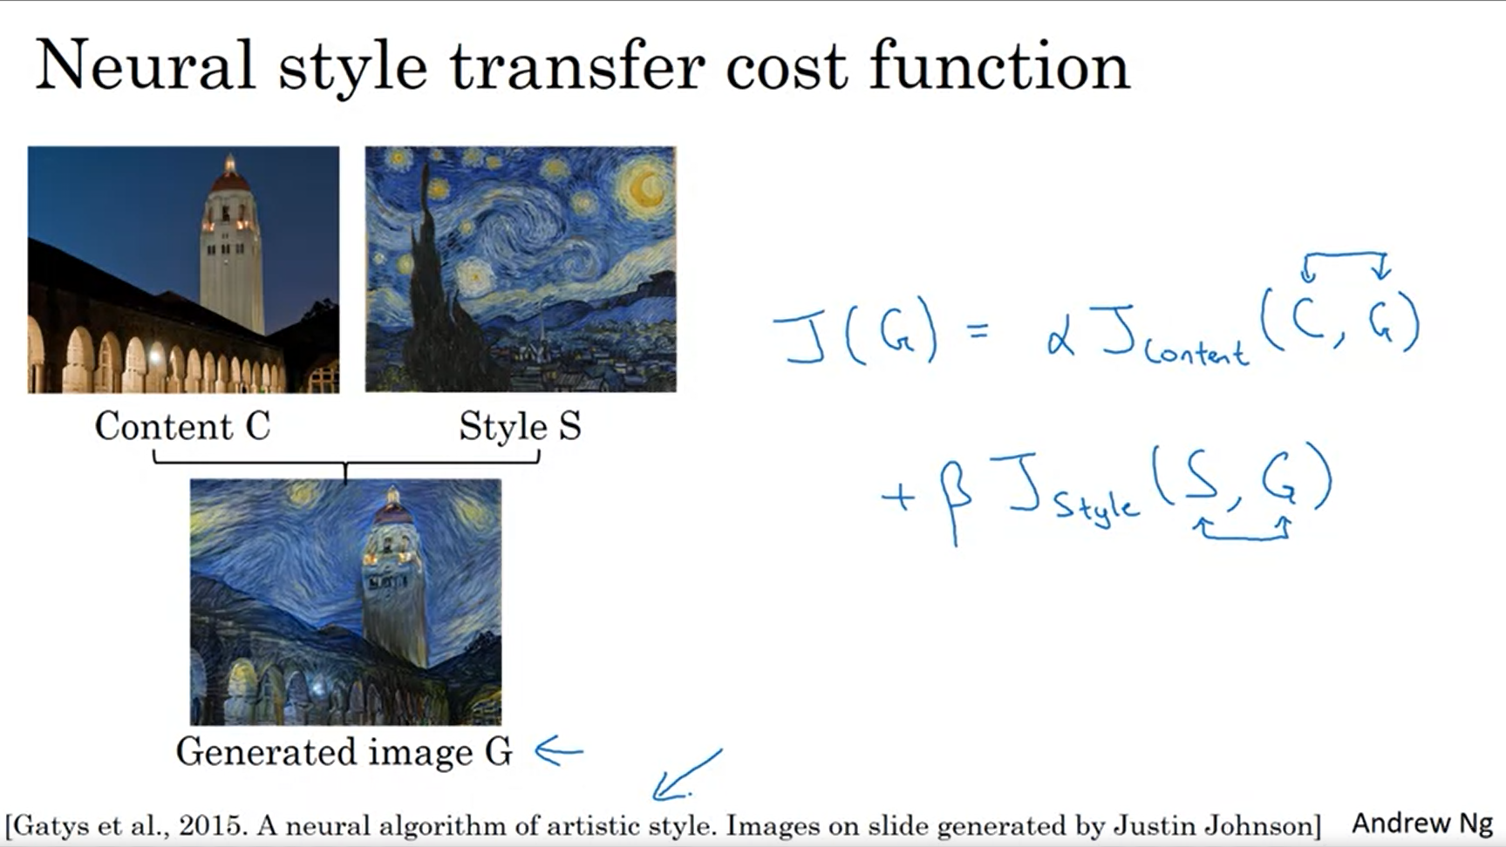

The cost function has two components: the content cost and the style cost. The content cost measures how similar is the content between the C and G image. The style cost measures how similar is the style between the S and G image.

Alpha and beta are hyperparameters to specify the relative weighting.

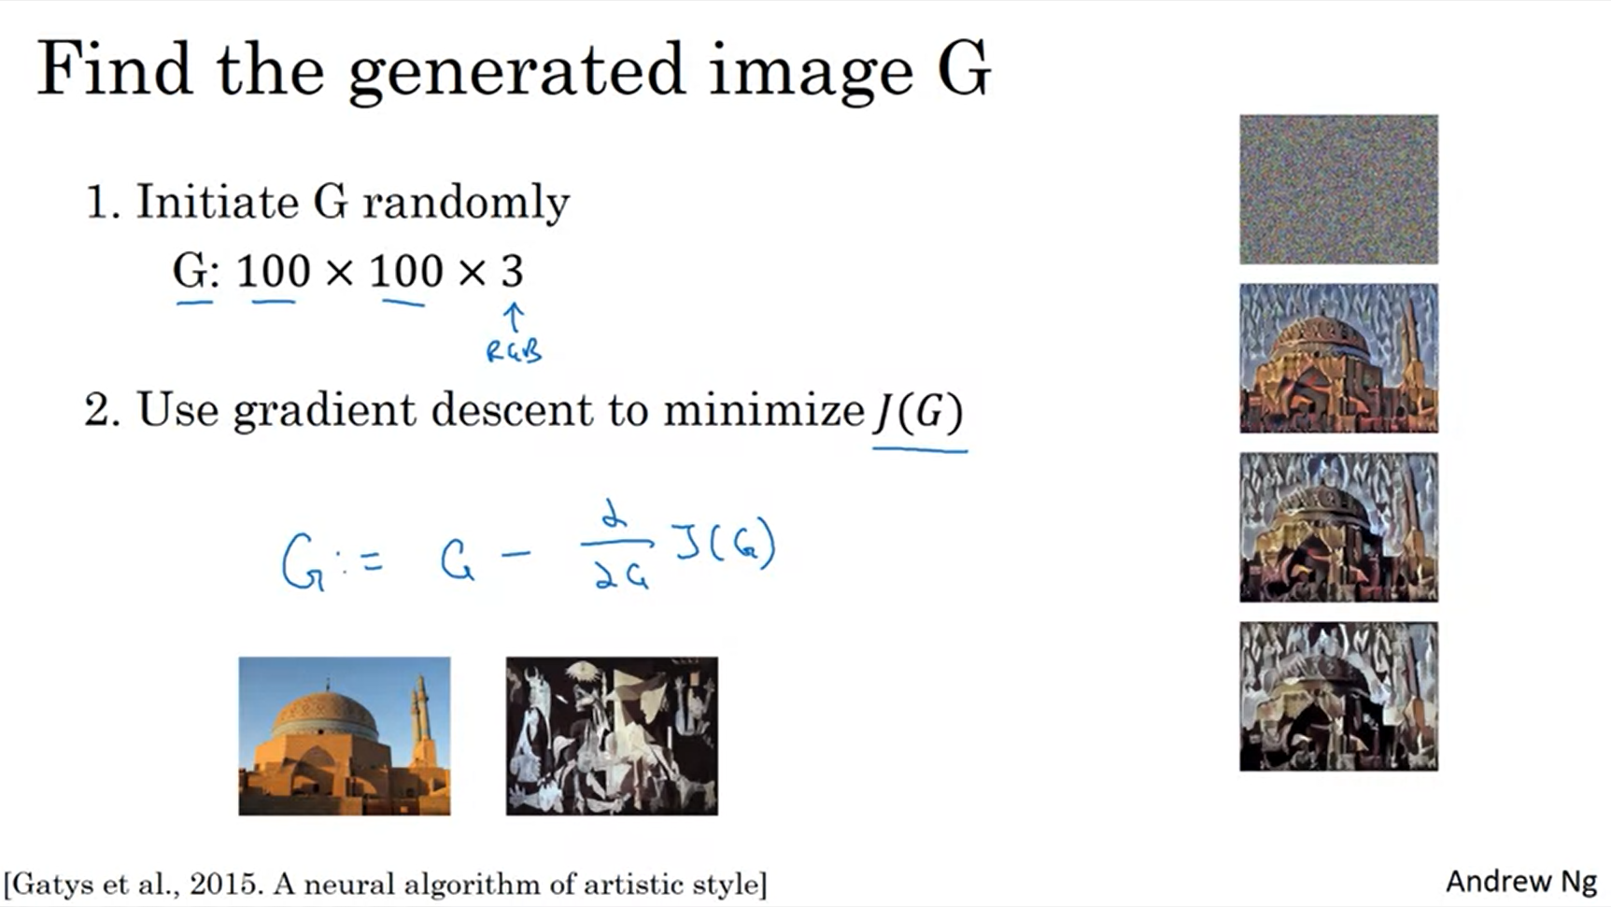

You tweak the pixel values directly using gradient descent.

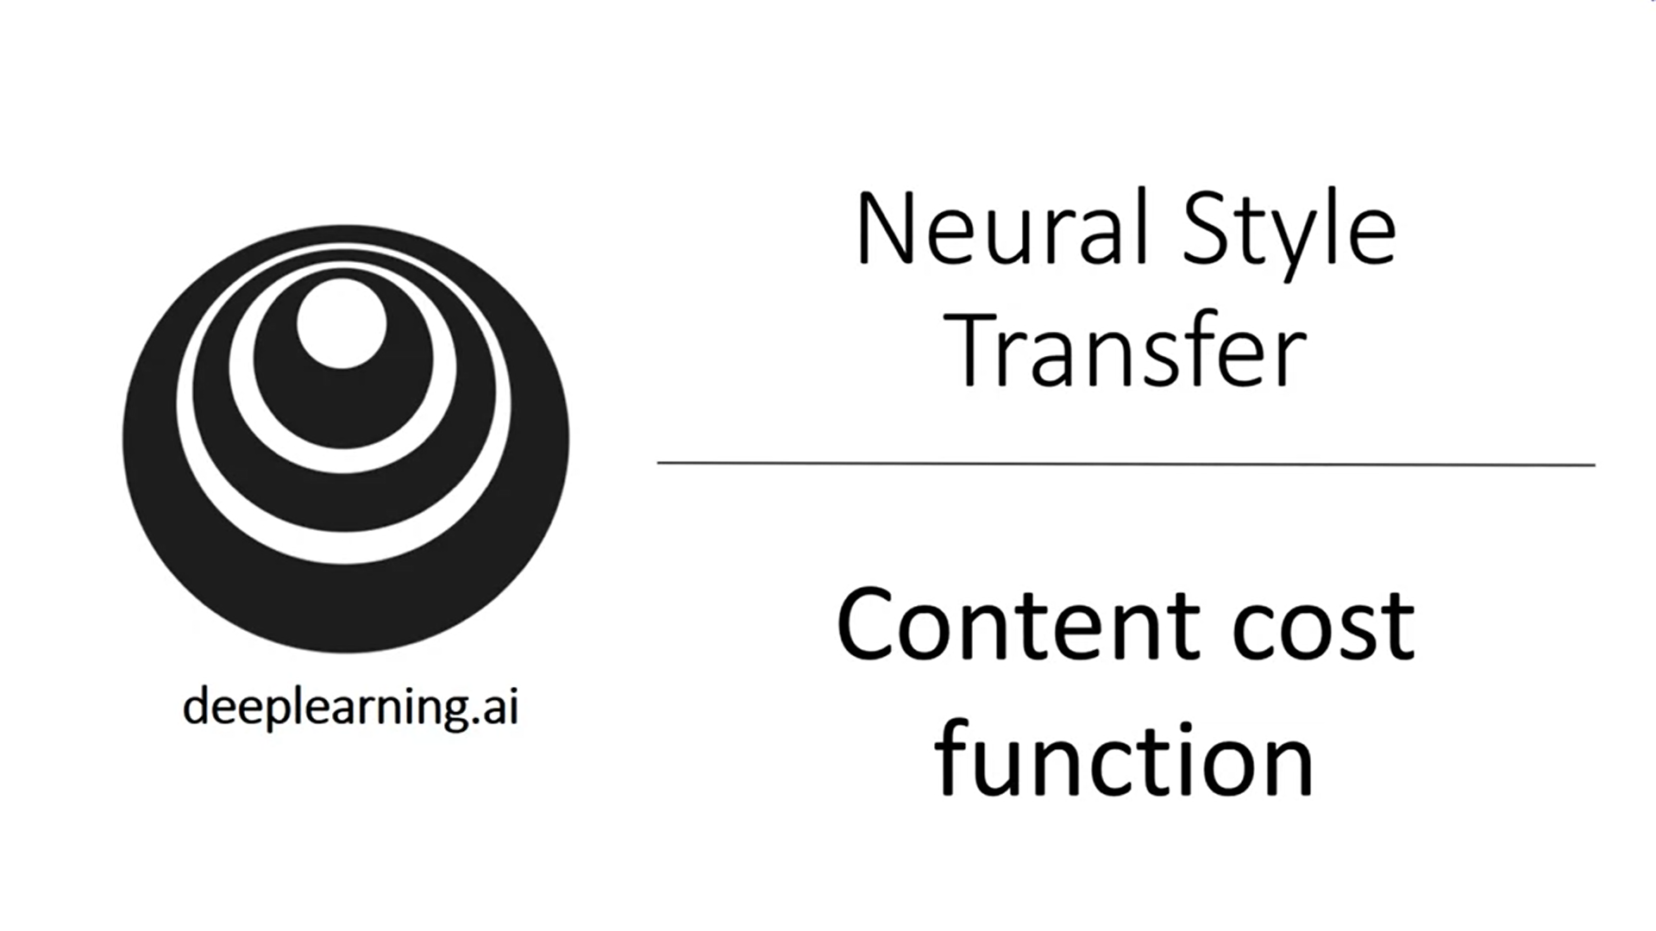

How to define the cost functions?

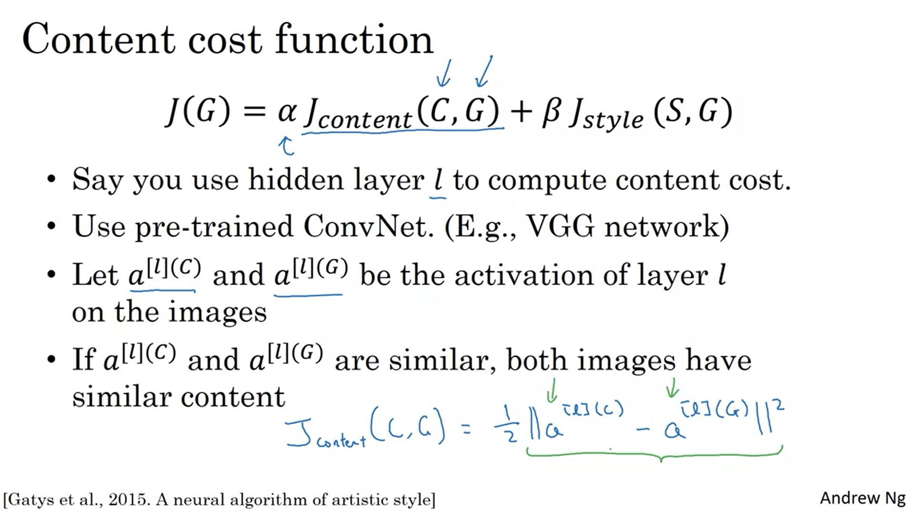

If l is a small number then it would really force the pixel values to be very similar to the content image.

If l is a deep layer it would for example already be enough if there is a dog in the image if there is a dog in the content image.

In practice the layer l chosen is in between: neither to deep nor to shallow.

Take the element-wise difference between the activations of the hidden layer l. Add normalization constant ½ (does not matter; it can be changed by alpha as well).

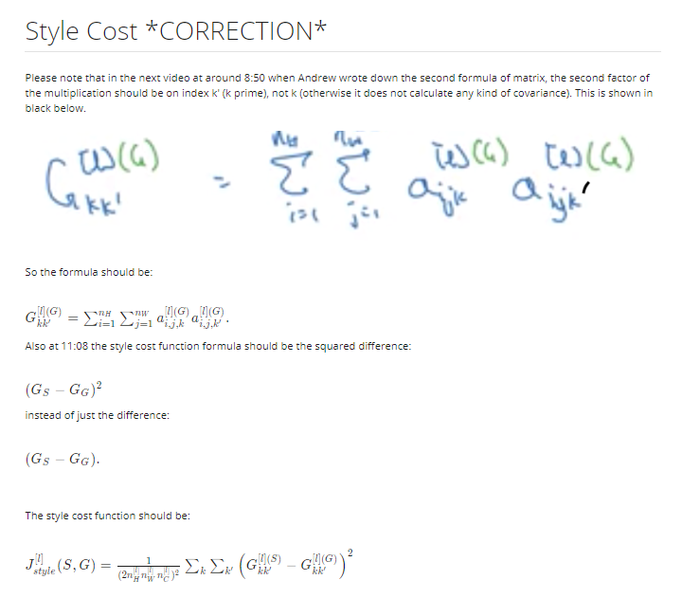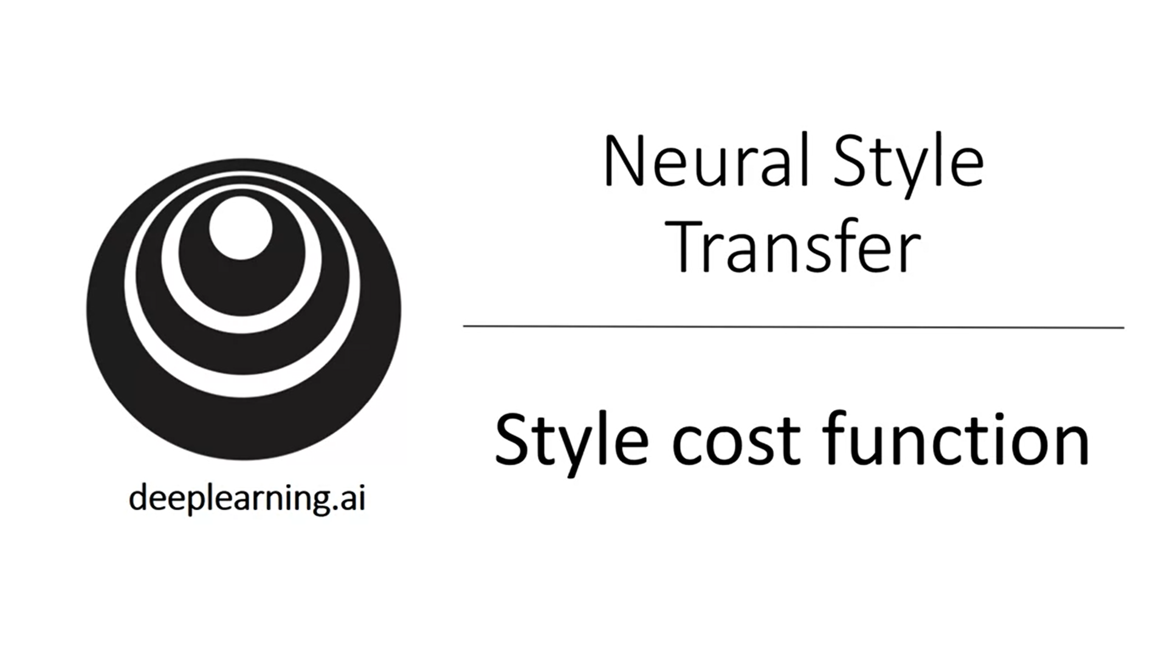

How to define the style cost function?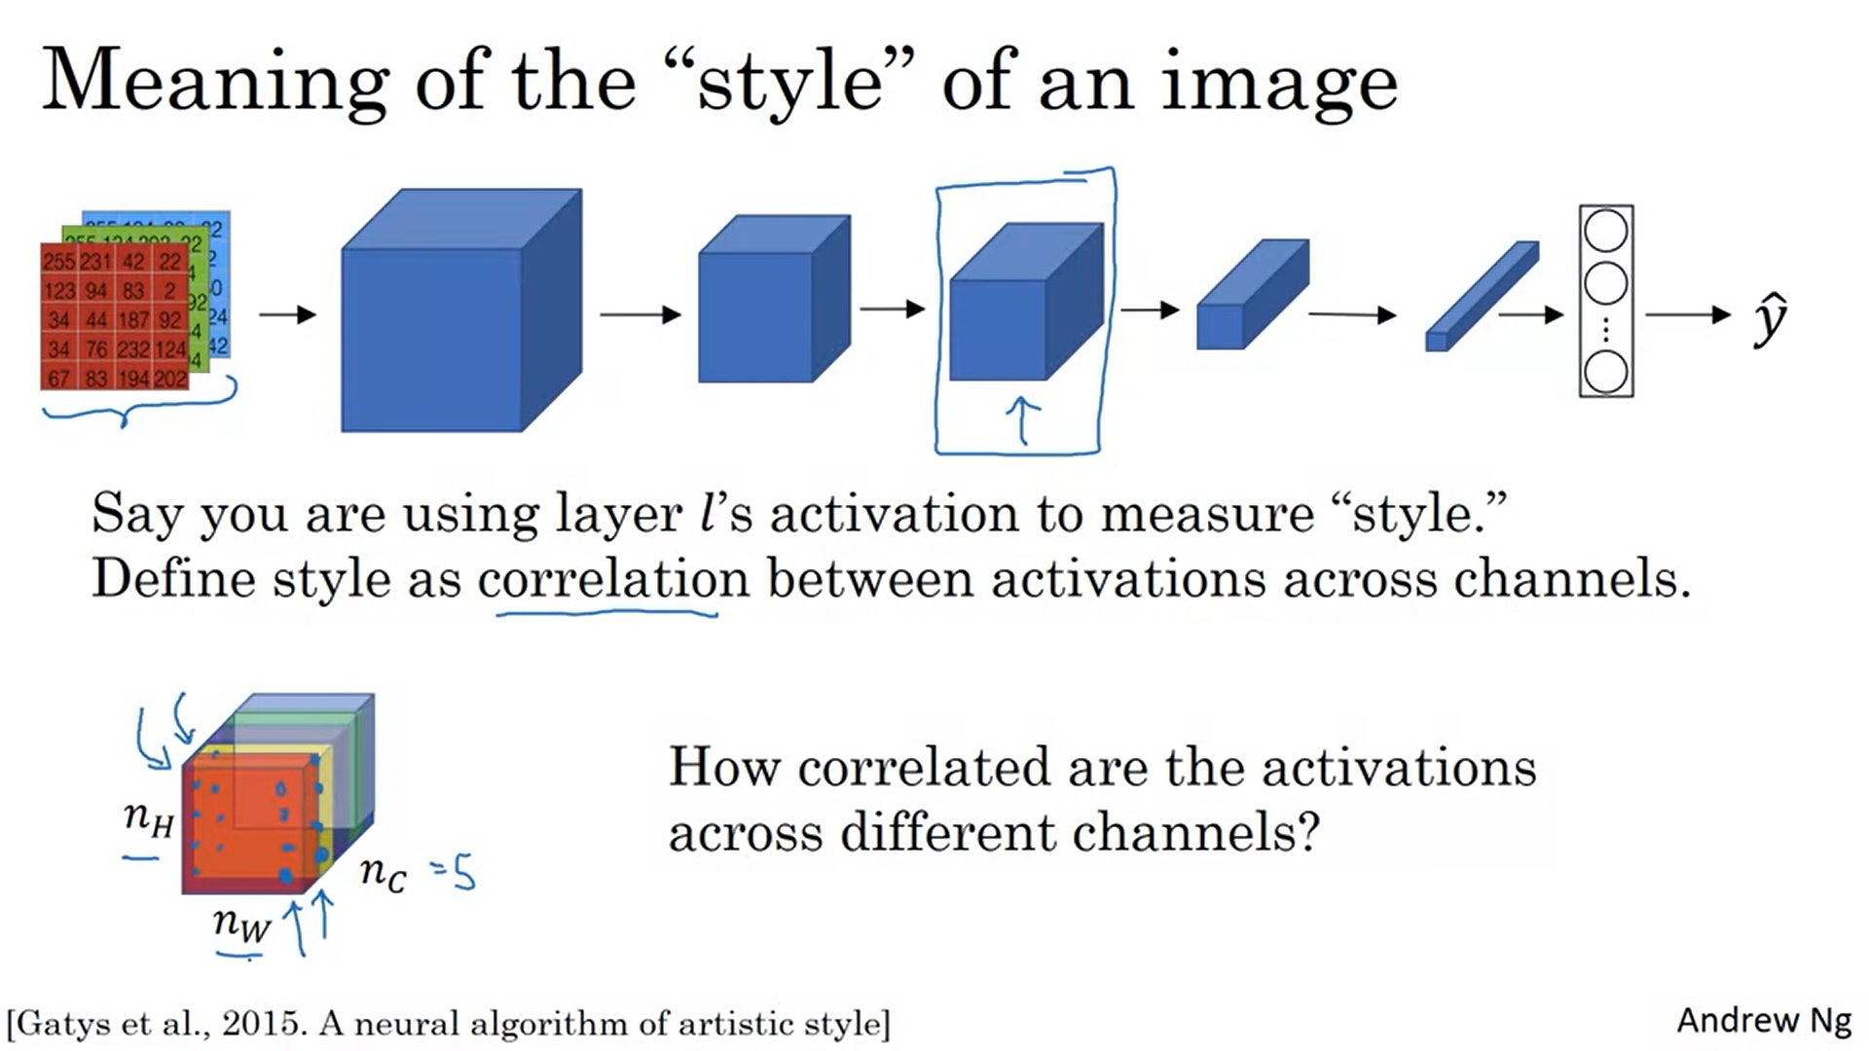

Example: 5 channels (to make the drawing easy), Let’s look at the first two channels. Look at different position pairs and see how correlated these numbers are across multiple positions.

Why does this measure style?

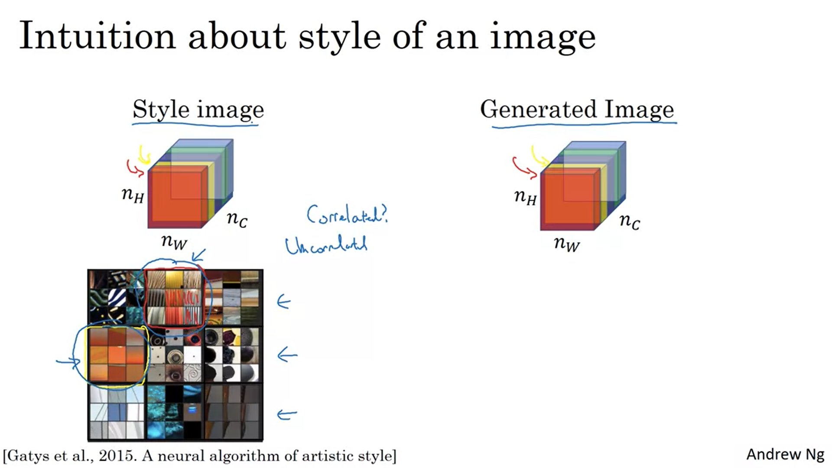

Let’s say for the sake of argument that the red channel corresponds to the middle top neuron (detecting vertical textures in the image) and the yellow channel corresponds to the left middle neuron (detecting orange-colored patches). What does it mean for these two channels to be highly correlated? It means that whenever a part of an image has a vertical texture it is also likely to be orange. Uncorrelated means the opposite. Correlation gives an indication how often these features occur together.

Let’s formalize this intuition.

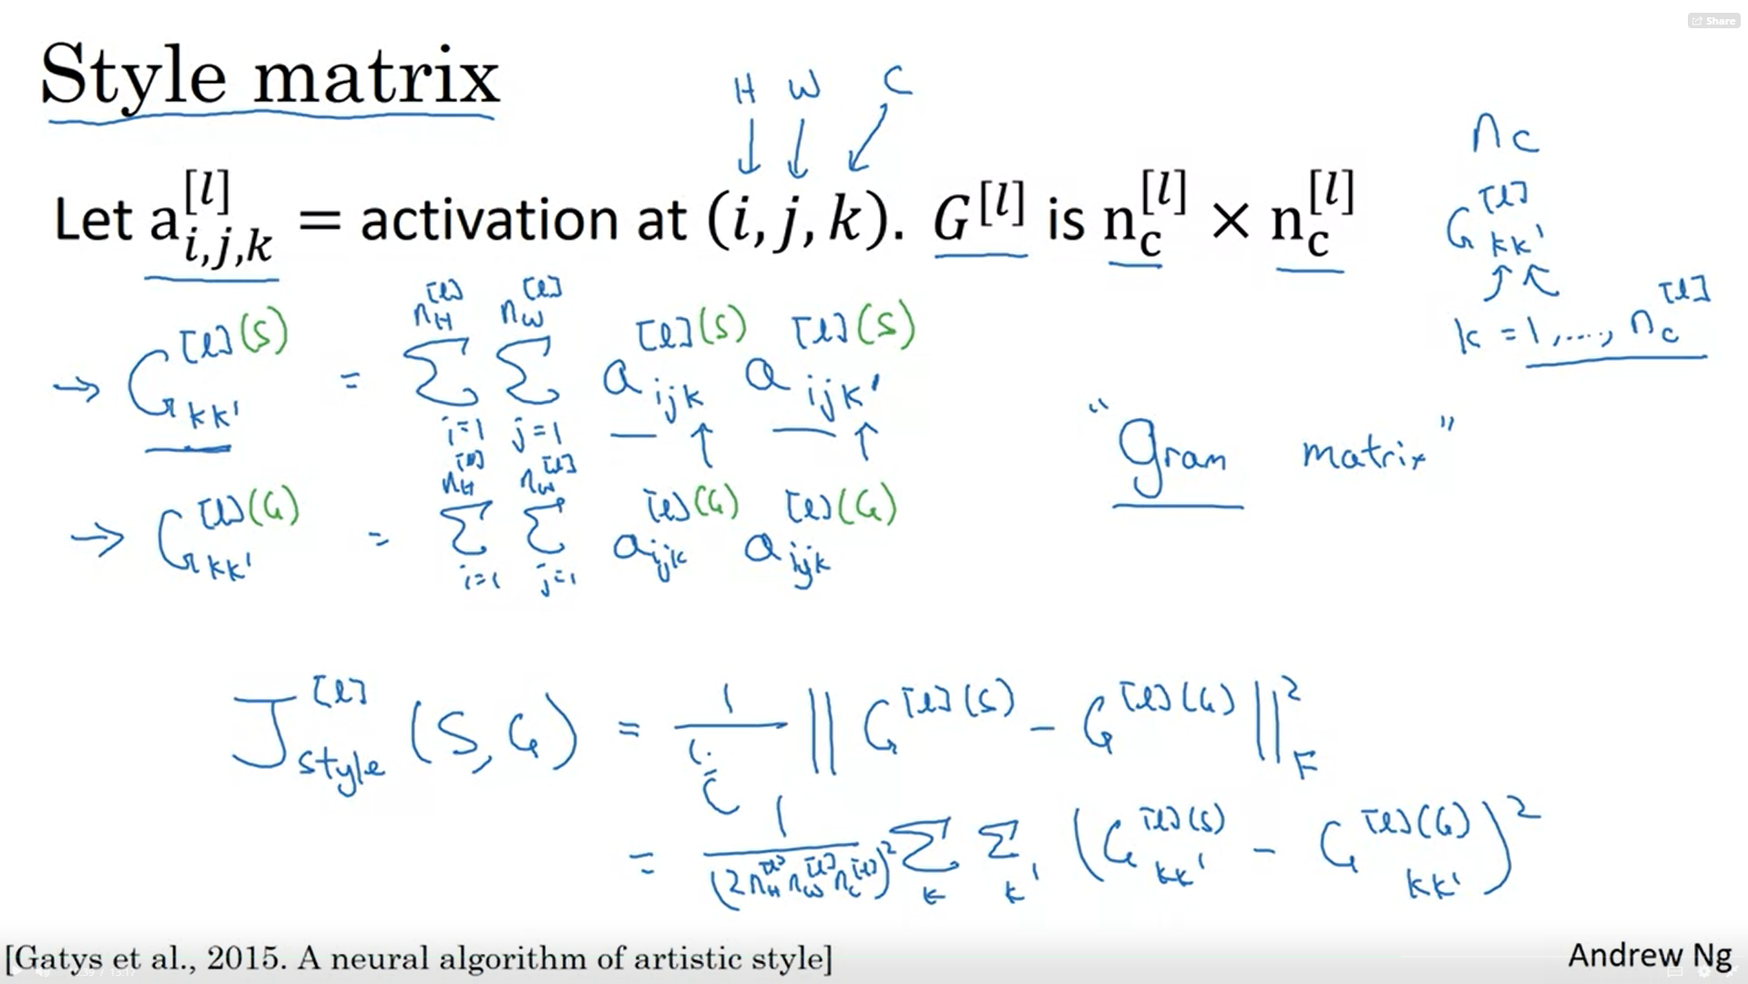

I indexes into the height, j indexes into the width and k indexes across the different channels.

We will compute a matrix G_l to contain correlations.

Above is the formula to compute one element of this matrix. It will calculate the correlation (through multiplication) across all activations of a channel. This matrix will hold a big value if the channels are highly correlated. This is actually the unnormalized covariance instead of correlation.

We will calculate this matrix for both the style image and the generated image. Then we have to matrices that capture the style of the two images respectively.

Finally the style cost function is the difference between these two matrices (frobenius norm). There is also a normalization factor but this does not matter so much because it changes with the hyperparameter beta anyways.

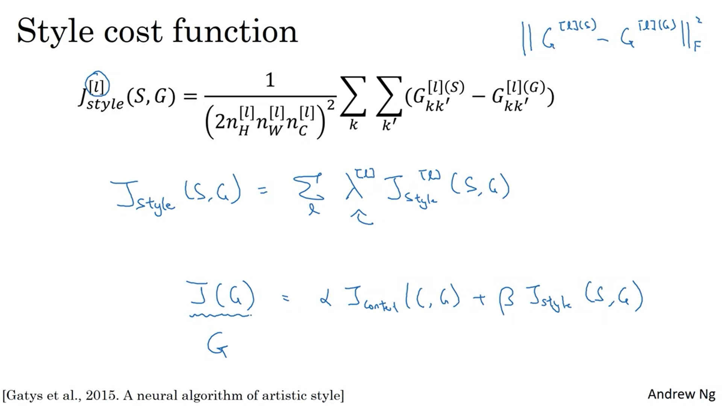

The results will be more visually pleasing if you take the style cost function from multiple layers. Each layer will be weighted with its lambda. Like this you force the neural network to take into account both low-level and high-level correlations.

Use gradient descent or more advanced optimization algorithm to generate G.

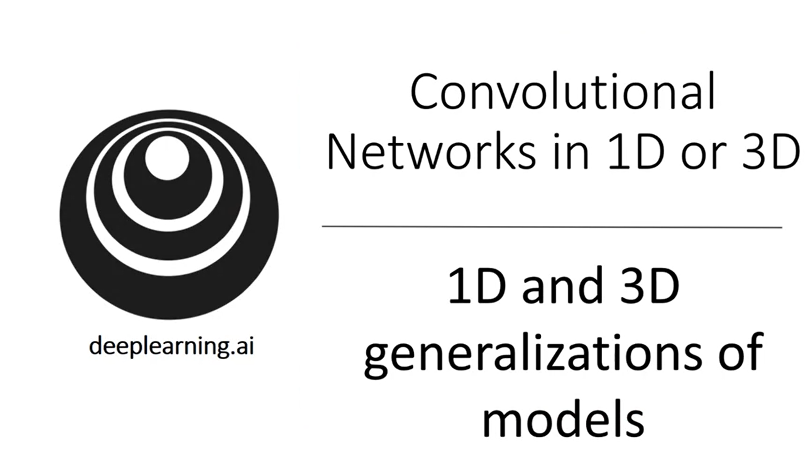

How to do convolutions over 1D and 3D data as opposed to 2D data?

Many of the ideas also apply to 1D and 3D data.

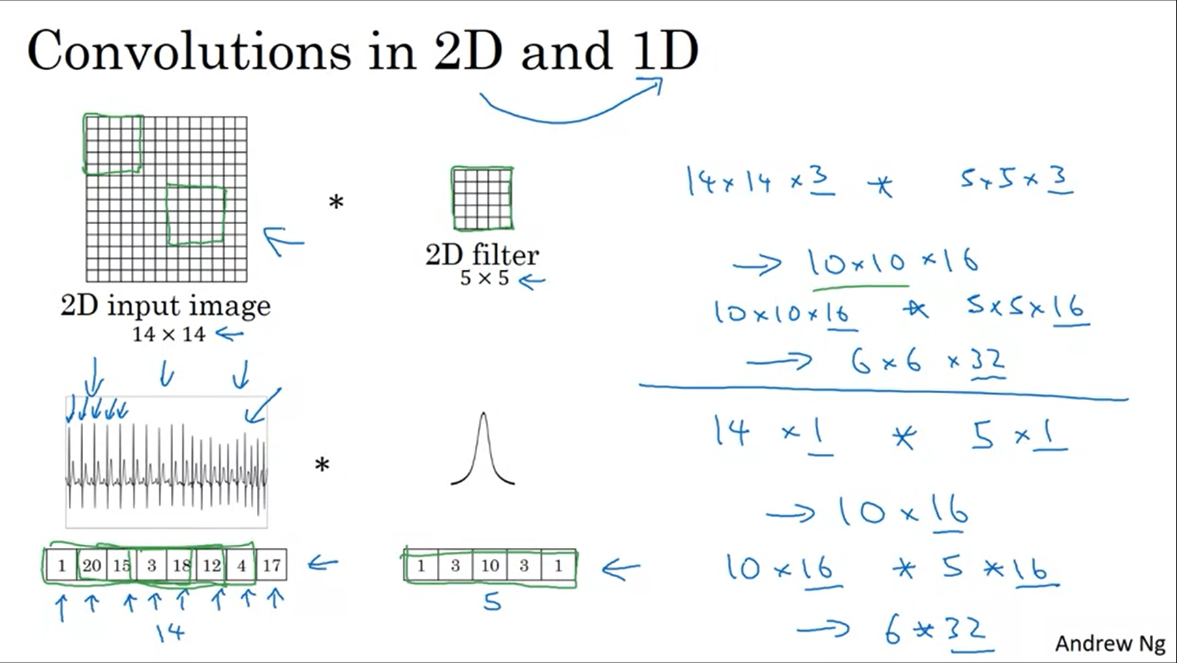

EGG signal (electrocardiogram) -> measure voltage in chest as heart beats. This is a timeseries of voltage. The convolution works the same way.

For most 1D data you use a recurrent neural network but some people also try to use convnets. We will talk about this in the next course.

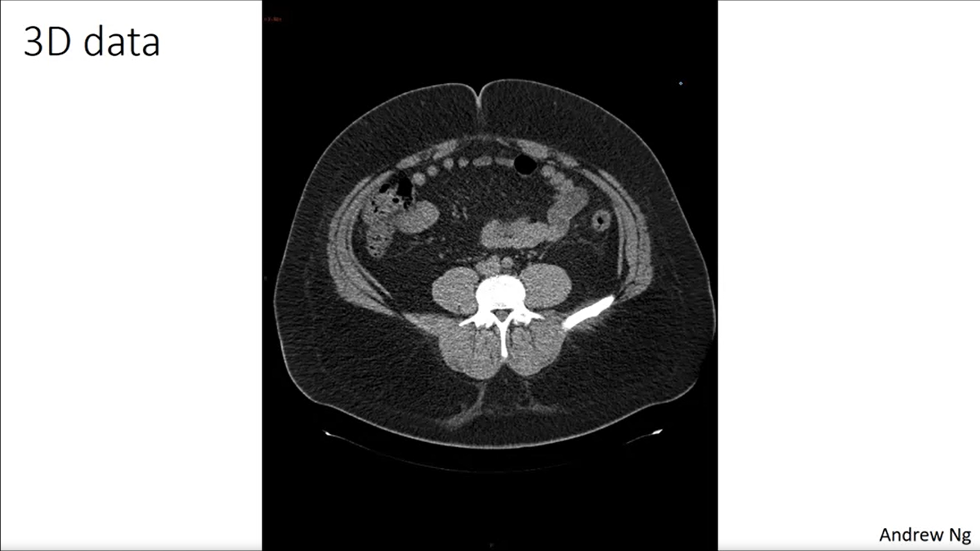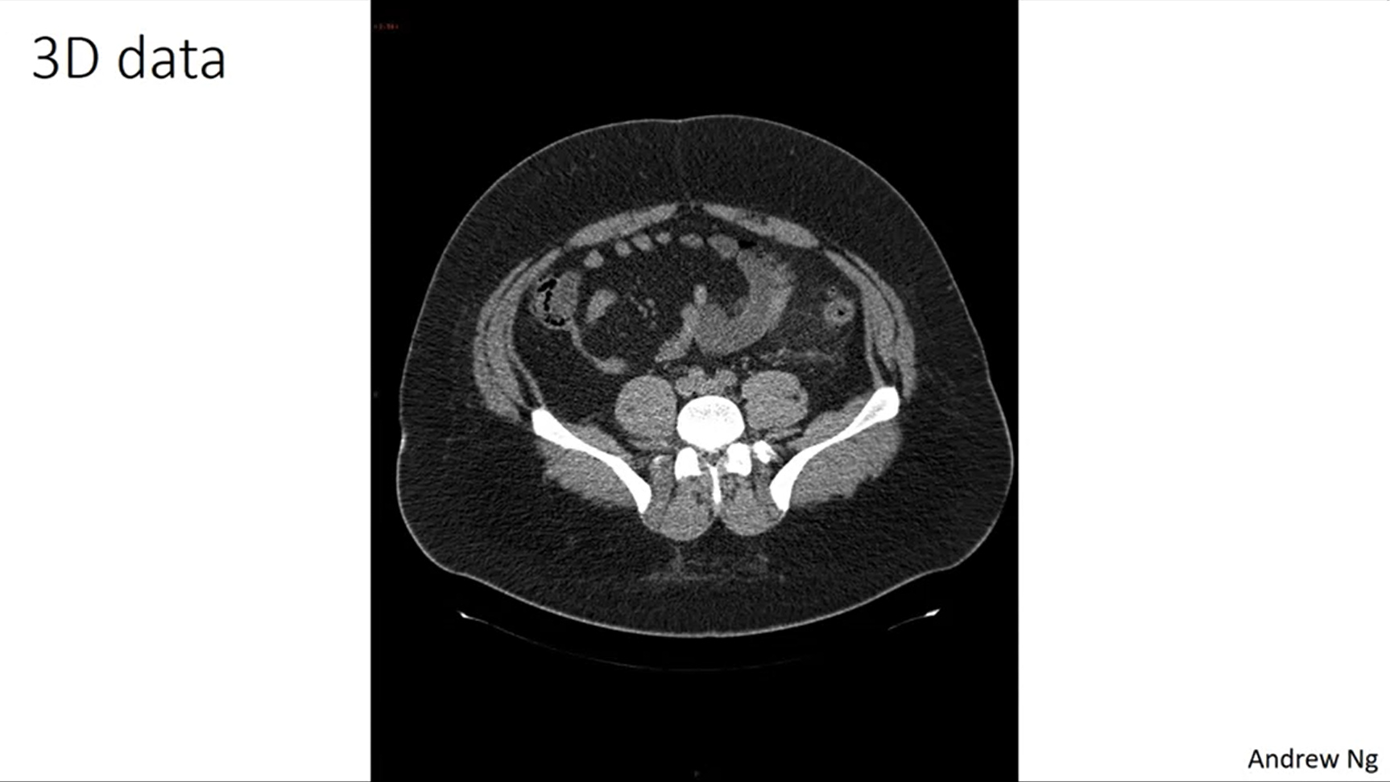

CT scan: 3D model of body (different slices of the human torso).

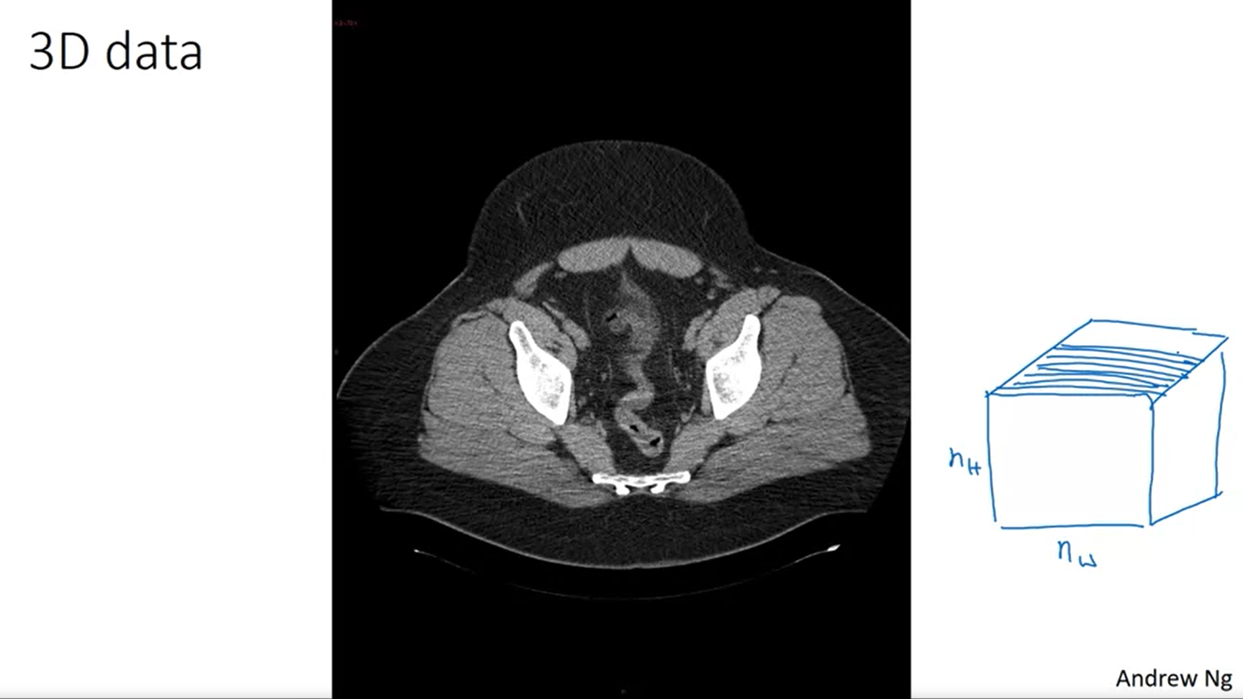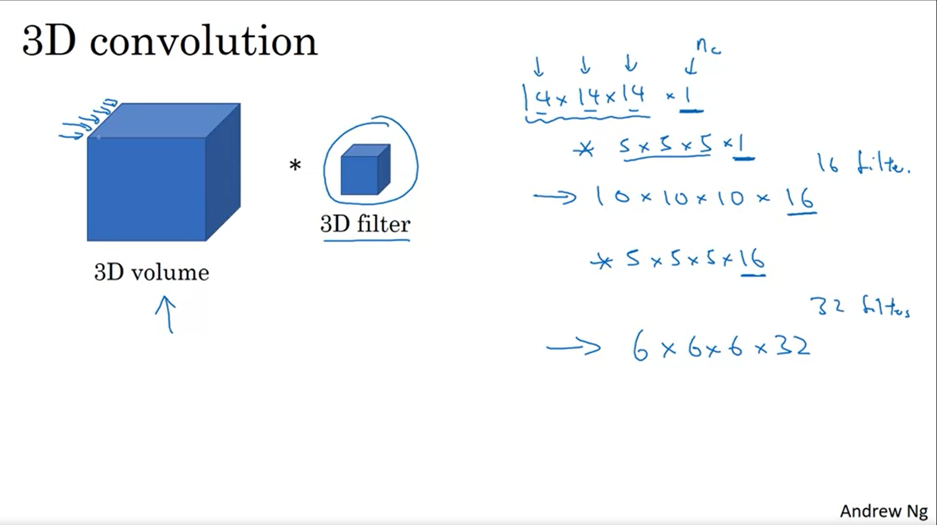

This does not have to be a perfect cube.

The filters will detect features across the 3D cube. Medical scans is one example. Movie data could be another example.

Image data is so pervasive that most applications of convnets are related to 2D data.